docker-compose cheatsheet
Your new development career awaits. Check out the latest listings.ads via Carbon

Basic example
# docker-compose.yml
version: '2'

services:
web:
build: .
# build from Dockerfile
context: ./Path
dockerfile: Dockerfile
ports:
- "5000:5000"
volumes:
- .:/code
redis:
image: redis

Commands
docker-compose start
docker-compose stop
docker-compose pause
docker-compose unpause
docker-compose ps
docker-compose up
docker-compose down

#Reference

Building
web:
# build from Dockerfile
build: .
args: # Add build arguments
APP_HOME: app
# build from custom Dockerfile
build:
context: ./dir
dockerfile: Dockerfile.dev
# build from image
image: ubuntu
image: ubuntu:14.04
image: tutum/influxdb
image: example-registry:4000/postgresql
image: a4bc65fd

Ports
ports:
- "3000"
- "8000:80" # host:container
# expose ports to linked services (not to host)
expose: ["3000"]

Commands
# command to execute
command: bundle exec thin -p 3000
command: [bundle, exec, thin, -p, 3000]
# override the entrypoint
entrypoint: /app/start.sh
entrypoint: [php, -d, vendor/bin/phpunit]

Environment variables
# environment vars
environment:
RACK_ENV: development
environment:
- RACK_ENV=development
# environment vars from file
env_file: .env
env_file: [.env, .development.env]

Dependencies
# makes the `db` service available as the hostname `database`
# (implies depends_on)
links:
- db:database
- redis
# make sure `db` is alive before starting
depends_on:
- db

Other options
# make this service extend another
extends:
file: common.yml # optional
service: webapp
volumes:
- /var/lib/mysql
- ./_data:/var/lib/mysql

#Advanced features

Labels
services:
web:
labels:
com.example.description: "Accounting web app"

DNS servers
services:
web:
dns: 8.8.8.8
dns:
- 8.8.8.8
- 8.8.4.4

Devices
services:
web:
devices:
- "/dev/ttyUSB0:/dev/ttyUSB0"

External links
services:
web:
external_links:
- redis_1
- project_db_1:mysql

Hosts
services:
web:
extra_hosts:
- "somehost:192.168.1.100"

Network
# creates a custom network called `frontend`
networks:
frontend:

External network
# join a pre-existing network
networks:
default:
external:
name: frontend

Volume
# Mount host paths or named volumes, specified as sub-options to a service
db:
image: postgres:latest
volumes:
- "/var/run/postgres/postgres.sock:/var/run/postgres/postgres.sock"
- "dbdata:/var/lib/postgresql/data"

volumes:
dbdata:
https://devhints.io/docker-compose

The Ultimate Docker Cheat Sheet

Complete Docker CLI
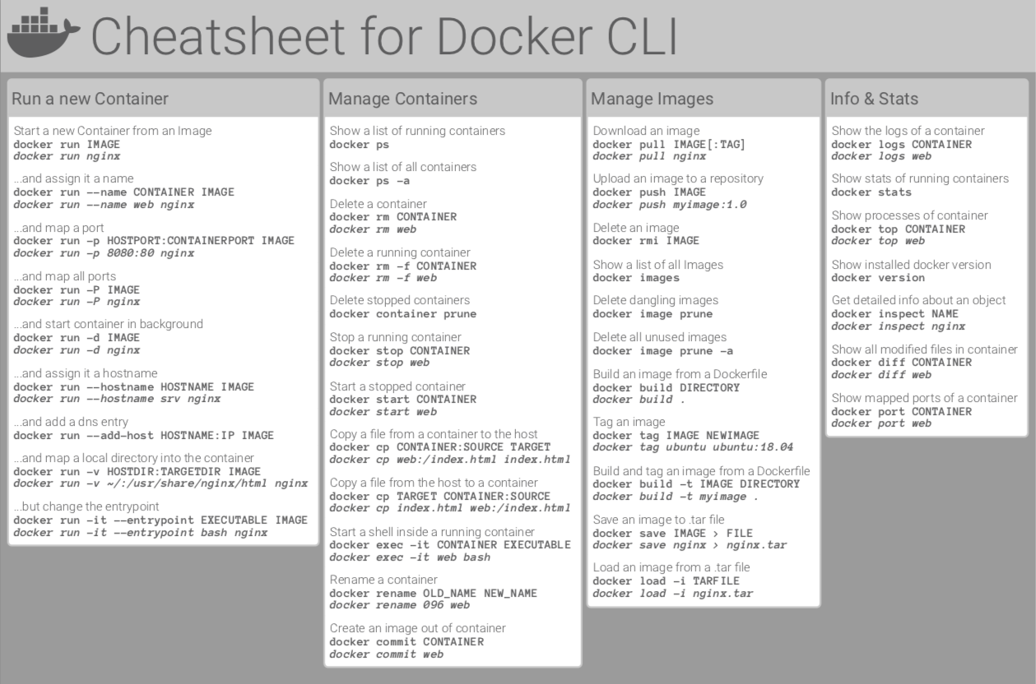

Container Management CLIs

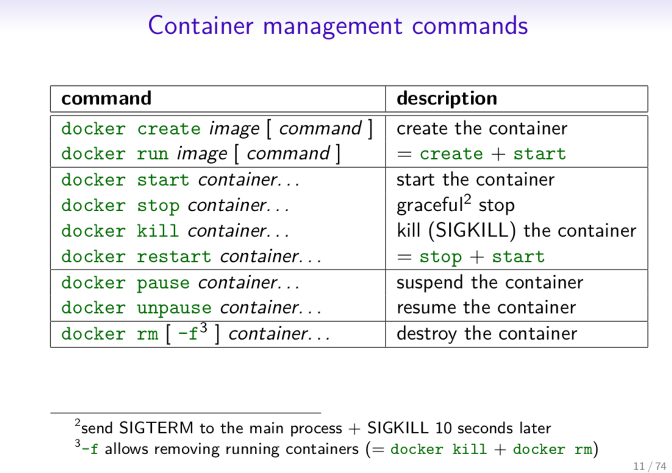

Inspecting The Container

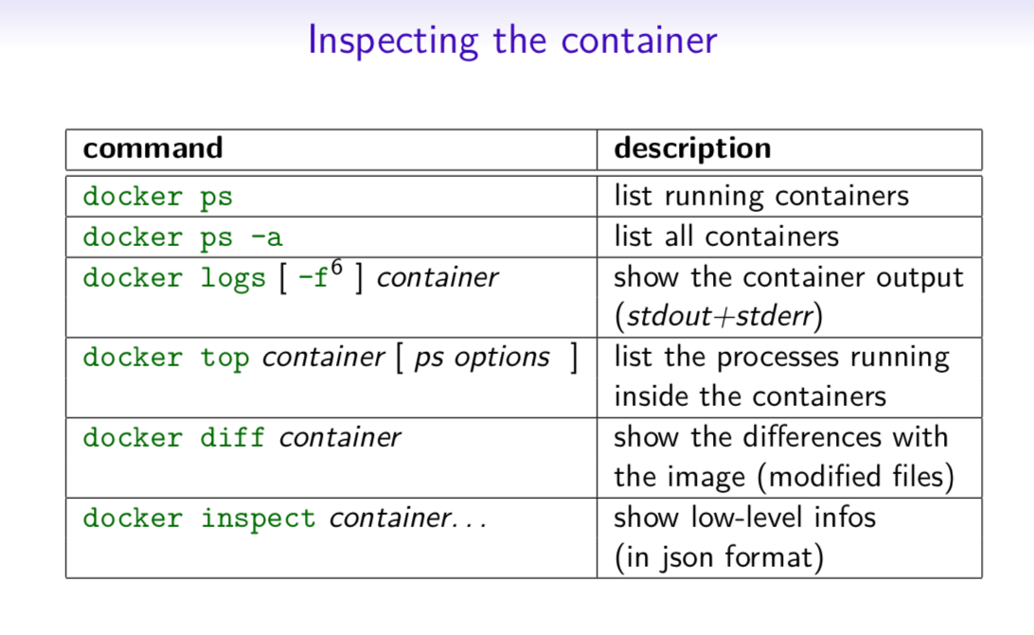

Interacting with Container
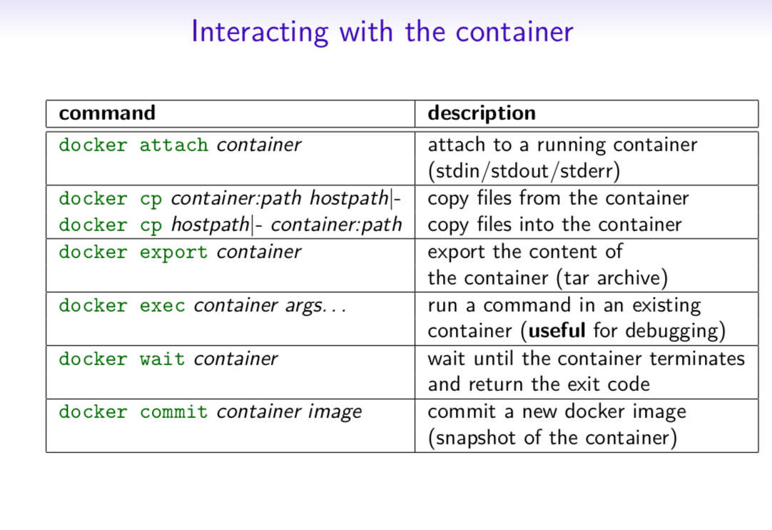

Image Management Commands

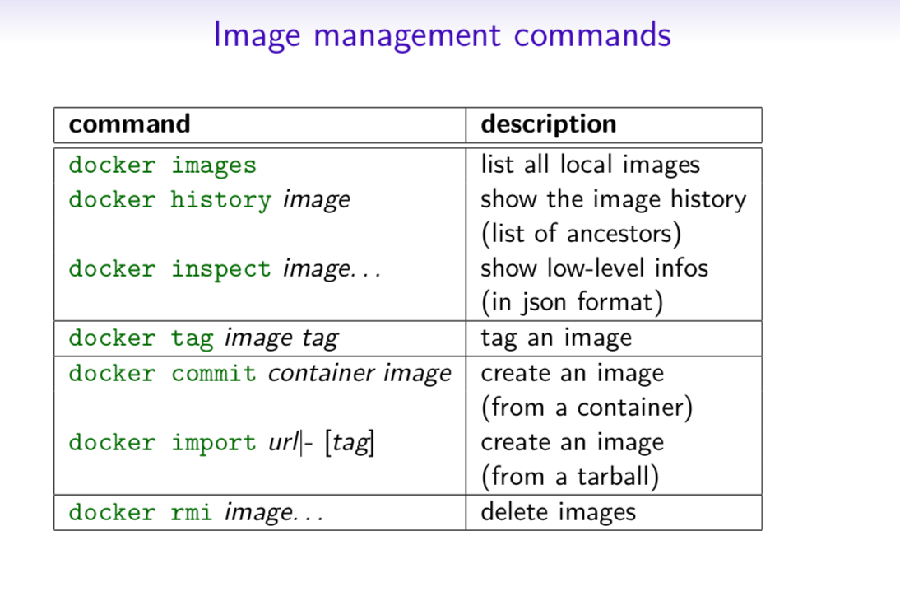

Image Transfer Commands

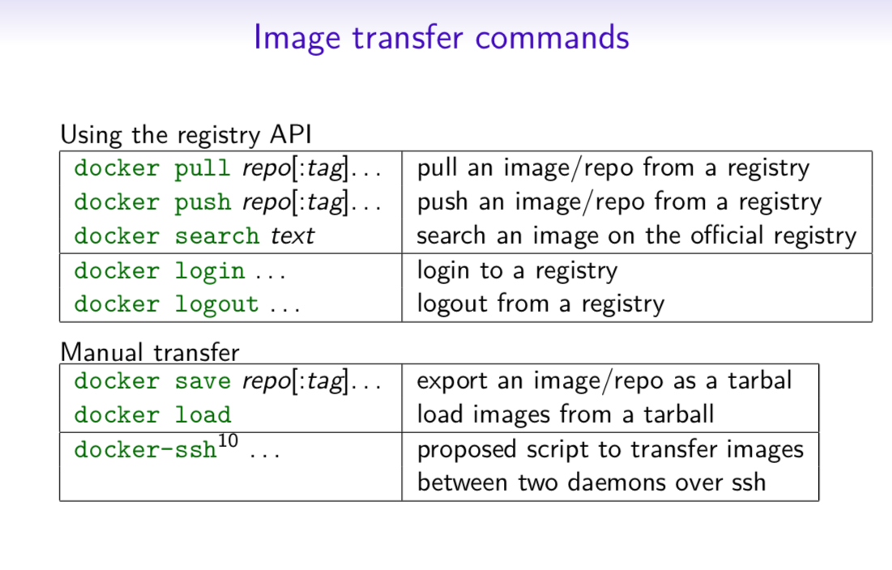

Builder Main Commands

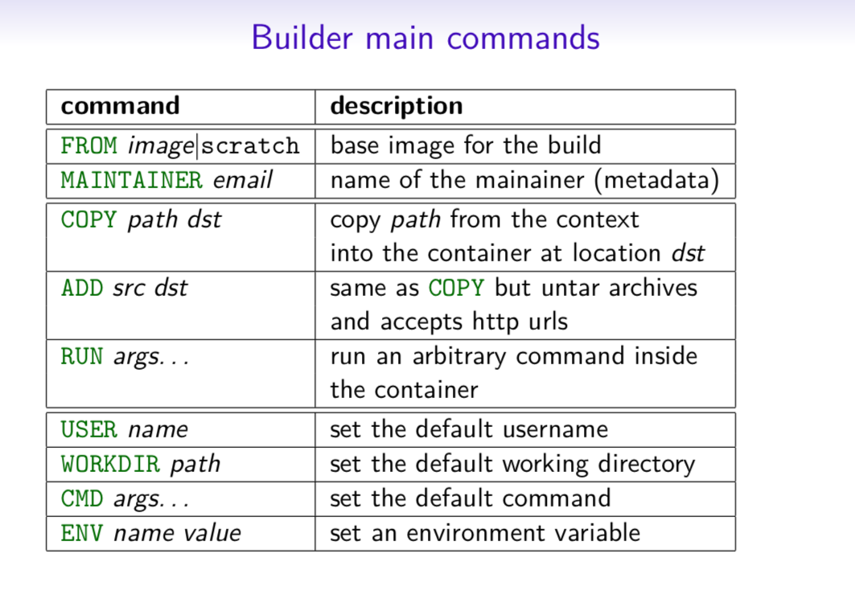

The Docker CLI

Manage images

docker build

docker build [options] .
-t "app/container_name" # name
Create an image from a Dockerfile.

docker run

docker run [options] IMAGE
# see `docker create` for options
Run a command in an image.

Manage containers

docker create

docker create [options] IMAGE
-a, --attach # attach stdout/err
-i, --interactive # attach stdin (interactive)
-t, --tty # pseudo-tty
--name NAME # name your image
-p, --publish 5000:5000 # port map
--expose 5432 # expose a port to linked containers
-P, --publish-all # publish all ports
--link container:alias # linking
-v, --volume `pwd`:/app # mount (absolute paths needed)
-e, --env NAME=hello # env vars

Example

$ docker create --name app_redis_1 \
--expose 6379 \
redis:3.0.2
Create a container from an image.

docker exec

docker exec [options] CONTAINER COMMAND
-d, --detach # run in background
-i, --interactive # stdin
-t, --tty # interactive

Example
$ docker exec app_web_1 tail logs/development.log
$ docker exec -t -i app_web_1 rails c
Run commands in a container.

docker start
docker start [options] CONTAINER
-a, --attach # attach stdout/err
-i, --interactive # attach stdin

docker stop [options] CONTAINER
Start/stop a container.

docker ps
$ docker ps
$ docker ps -a
$ docker kill $ID
Manage containers using ps/kill.

Images

docker images
$ docker images
REPOSITORY TAG ID
ubuntu 12.10 b750fe78269d
me/myapp latest 7b2431a8d968
$ docker images -a # also show intermediate
Manages images.

docker rmi
docker rmi b750fe78269d
Deletes images.

Also see
- Getting Started (docker.io)

Dockerfile

Inheritance
FROM ruby:2.2.2

Variables
ENV APP_HOME /myapp
RUN mkdir $APP_HOME

Initialization
RUN bundle install
WORKDIR /myapp
VOLUME ["/data"]
# Specification for mount point
ADD file.xyz /file.xyz
COPY --chown=user:group host_file.xyz /path/container_file.xyz

Onbuild
ONBUILD RUN bundle install
# when used with another file

Commands
EXPOSE 5900
CMD ["bundle", "exec", "rails", "server"]

Entrypoint
ENTRYPOINT ["executable", "param1", "param2"]
ENTRYPOINT command param1 param2
Configures a container that will run as an executable.
ENTRYPOINT exec top -b
This will use shell processing to substitute shell variables, and will ignore any CMD or docker run command line arguments.

Metadata
LABEL version="1.0"
LABEL "com.example.vendor"="ACME Incorporated"
LABEL com.example.label-with-value="foo"
LABEL description="This text illustrates \
that label-values can span multiple lines."

See also
- https://docs.docker.com/engine/reference/builder/

docker-compose

Basic example
# docker-compose.yml
version: '2'

services:
web:
build: .
# build from Dockerfile
context: ./Path
dockerfile: Dockerfile
ports:
- "5000:5000"
volumes:
- .:/code
redis:
image: redis

Commands
docker-compose start
docker-compose stop
docker-compose pause
docker-compose unpause
docker-compose ps
docker-compose up
docker-compose down

Reference

Building
web:
# build from Dockerfile
build: .
# build from custom Dockerfile
build:
context: ./dir
dockerfile: Dockerfile.dev
# build from image
image: ubuntu
image: ubuntu:14.04
image: tutum/influxdb
image: example-registry:4000/postgresql
image: a4bc65fd

Ports
ports:
- "3000"
- "8000:80" # guest:host
# expose ports to linked services (not to host)
expose: ["3000"]

Commands
# command to execute
command: bundle exec thin -p 3000
command: [bundle, exec, thin, -p, 3000]
# override the entrypoint
entrypoint: /app/start.sh
entrypoint: [php, -d, vendor/bin/phpunit]

Environment variables
# environment vars
environment:
RACK_ENV: development
environment:
- RACK_ENV=development
# environment vars from file
env_file: .env
env_file: [.env, .development.env]

Dependencies
# makes the `db` service available as the hostname `database`
# (implies depends_on)
links:
- db:database
- redis
# make sure `db` is alive before starting
depends_on:
- db

Other options
# make this service extend another
extends:
file: common.yml # optional
service: webapp
volumes:
- /var/lib/mysql
- ./_data:/var/lib/mysql

Advanced features

Labels
services:
web:
labels:
com.example.description: "Accounting web app"

DNS servers
services:
web:
dns: 8.8.8.8
dns:
- 8.8.8.8
- 8.8.4.4

Devices
services:
web:
devices:
- "/dev/ttyUSB0:/dev/ttyUSB0"

External links
services:
web:
external_links:
- redis_1
- project_db_1:mysql

Hosts
services:
web:
extra_hosts:
- "somehost:192.168.1.100"

sevices
To view list of all the services runnning in swarm
docker service ls

To see all running services
docker stack services stack_name
to see all services logs
docker service logs stack_name service_name
To scale services quickly across qualified node
docker service scale stack_name_service_name=replicas

clean up
To clean or prune unused (dangling) images
docker image prune
To remove all images which are not in use containers , add - a
docker image prune -a
To prune your entire system
docker system prune
To leave swarm
docker swarm leave
To remove swarm ( deletes all volume data and database info)
docker stack rm stack_name
To kill all running containers
docker kill $(docekr ps -q )

Contributor -
Sangam biradar - Docker Community Leader

Practice Docker Tutorial
Tweets by collabnix dockerlabs is maintained by collabnix. This page was generated by GitHub Pages.

https://dockerlabs.collabnix.com/docker/cheatsheet/

Docker Cheat Sheet
By Hemant Sharma 4.1 K Views 19 min read Updated on December 24, 2021
This Docker cheat sheet, along with the quick explanations on all the common Docker commands, will help you be up and running while working in the domain of Docker.

Docker Commands Cheat Sheet
Are you finding difficulty remembering all the commands that you need in order to work with Docker?
Guys, don’t worry! This Docker cheat sheet will give you a quick reference to the basics of Docker that you must know to get started with it.
At Intellipaat, we support our learners with a handy reference, that’s the reason we have created this cheat sheet. It is designed for those who have already started learning Docker but need a handy reference to recall the concepts that they have learned.
Download a Printable PDF of This Cheat Sheet
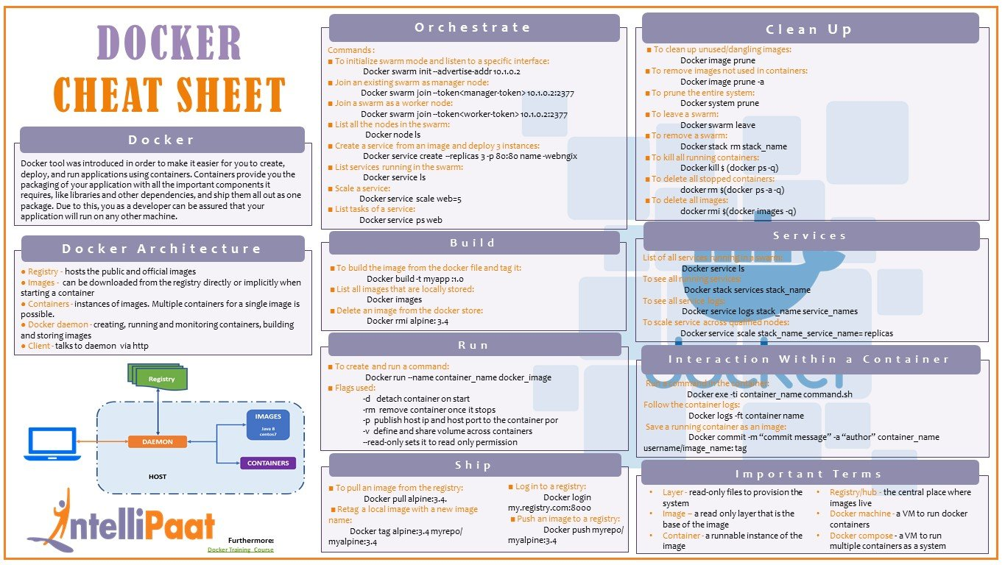

Introduction
The Docker tool was introduced to make it easier for developers to create, deploy, and run applications using containers. Containers provision the developers with the packaging of their applications, together with all important components they require such as libraries and other dependencies, and shipping of them all out as a single package. This assures the developers that their applications can be run on any other machine.
We will start this tutorial by understanding the Docker architecture and the main aspects in it, and then we will continue with the important commands required for the Docker operations, such as Docker installation, build, push, run, ship, clean up, and the interaction with the container.
Become a master of DevOps by enrolling in this online DevOps Training in London!

Docker Architecture
DevOps architecture consists of five main entities, namely, registry, image, container, daemon, and client.
- Registry: It hosts public and official images. The Docker registry that we use is Docker Hub.
- Image: It can be downloaded from the registry directly or implicitly when starting a container.
- Container: It is basically the instance of an image. Multiple containers can exist for a single image.
- Docker daemon: A daemon creates, runs, and monitors containers, along with building and storing images.
- Client: A client talks to Docker daemon via HTTP.
Join the Best DevOps Course in New York to get a clear understanding of DevOps!

Orchestrate
Orchestration is used for managing a container’s life cycle, especially in dynamic environments. It is used for controlling and automating many tasks for containers.
There are many Docker orchestration tools such as Docker Swarm, Kubernetes, etc. In this tutorial, we’re elucidating Docker Swarm commands. Let’s check out the commands used for Docker orchestration.
Learn more about DevOps in this DevOps Training in Sydney and get ahead in your career!

Commands
- To initialize the swarm mode and listen to a specific interface:
Docker swarm init --advertise-addr 10.1.0.2
- To join an existing swarm as a manager node:
Docker swarm join --token<manager-token> 10.1.0.2:2377
- To join a swarm as a worker node:
Docker swarm join --token<worker-token> 10.1.0.2:2377
- To list all nodes in the swarm:
Docker node ls
- To create a service from an image on the existing port and deploy three instances:
Docker service create --replicas 3 -p 80:80 name -webngix
- To list services running in a swarm:
Docker service ls
- To scale a service:
Docker service scale web=5
- To list the tasks of a service:
Docker service ps web
Equip yourself with these Top DevOps Interview Questions and Answers to ace your career!

Build
The build command is used for building images from a Docker file. Let’s now check out some of the essential Docker build commands.

Commands
- To build an image from the Docker file and tag it:
Docker build -t myapp :1.0
- To list all the images that are locally stored:
Docker images
- To delete an image from the Docker Store:
Docker rmi alpine: 3.4
Do you have queries related to DevOps? Visit our DevOps Community and get your queries clarified by the DevOps experts!

Run
The run command is used for creating a container from a specified image. Check out the below-listed run commands.

Commands
- To create and run a command:
Docker run --name container_name docker_image
Flags used:
- -d: To detach a container on start
- -rm: To remove a container once it stops
- -p: To publish the host IP and the host port to the container port
- -v: To define and share the volume across containers
- –read-only: To set to the read-only permission

Ship
Docker gives us the capability of shipping our application container anywhere, on any platform. Let’s check out some commands used for it.

Commands
- To pull an image from the registry:
Docker pull alpine:3.4
- To retag a local image with a new image name:
Docker tag alpine:3.4 myrepo/ myalpine:3.4
- To log in to the registry:
Docker login my.registry.com:8000
- To push an image to the registry:
Docker push myrepo/ myalpine:3.4
Interested in becoming a DevOps expert? Visit DevOps Course in Toronto and enroll today!

Clean up
To prevent wasting resources, we must know how to clean up. In this Docker cheat sheet tutorial, next, a few essential clean-up commands are provided.

Commands
- To clean an unused/dangling image:
Docker image prune
- To remove an image that is not used in a container:
Docker image prune -a
- To prune the entire system:
Docker system prune
- To leave a swarm:
Docker swarm leave
- To remove a swarm:
Docker stack rm stack_name
- To kill all running containers:
Docker kill $ (docker ps -q)
- To delete all stopped containers:
docker rm $(docker ps -a -q)
- To delete all images:
docker rmi $(docker images -q)

Services
Let’s now take a sneak peek at the commands used to view the running services, to run the services, to view all service logs, and to scale the services.

Commands
To list all services running in a swarm:
Docker service ls
To see all running services:
Docker stack services stack_name
To see all service logs:
Docker service logs stack_name service_names
To scale a service across qualified nodes:
Docker service scale stack_name_service_name= replicas
Interested in getting an industry-recognized certification in DevOps? Enroll in Intellipaat’s DevOps Course in Bangalore today!

Interaction with a Container
Let’s check out how to make an interaction with a container in Docker.

Commands
To run a command in a container:
Docker exe -ti container_name command.sh
To follow container logs:
Docker logs -ft container name
To save a running container as an image:
Docker commit -m “commit message” -a “author” container_name username/image_name: tag
DevOps Engineers are among the highest paid professionals in the technology domain. So why wait? Join the next batch of DevOps Training in Hyderabad!

Important Terms
Some of the important terms to know about while using Docker containers are listed below:
- Layer: Read-only files to provision the system
- Image: Read-only layer that is the base of an image
- Container: A runnable instance of the image
- Registry/hub: A central place where images reside
- Docker machine: A VM to run Docker containers
- Docker Compose: A VM to run multiple containers as a system
Download a Printable Docker Cheat Sheet PDF
We have covered all the basics of Docker in this Docker commands cheat sheet. If you want to start learning DevOps in-depth, then check out the DevOps certification training offered by Intellipaat.
Not only will you get to learn and implement Docker with step-by-step guidance and support from us but you will also get to learn other important topics in DevOps such as Chef, Git/GitHub, Ansible, Jenkins, Puppet, Selenium, Nagios, and many more.
Here, at Intellipaat, you will also get 24/7 technical support from us that will help you with any of your queries in the respective technologies throughout the certification period. So, why wait? Check out the training program and enroll today!
Get in touch with Intellipaat for enrolling in its DevOps Training and being a certified DevOps Engineer!
https://intellipaat.com/blog/tutorial/devops-tutorial/docker-cheat-sheet/

Docker Cheat Sheet
Container run
Container is runtime environments for an image. When we do docker pull <image>, the container is not started nor created yet.
We most commonly used command is the docker run <image> command. It downloads the image if it's not already in our local machine and starts the container once the image is ready.
- docker create: creates a writable container layer over the specified image and prepares it for running the specified command. The container ID is then printed to STDOUT. This is similar to docker run -d except the container is never started. We can then use the docker start <container_id> command to start the container at any point.
$ docker create -t -i fedora bash
...
dff32a272ad4c94cd51419ee4f53c371e3c3a8cfb448a469634d4420e139d118

$ docker start -a -i dff32a272ad4c
[root@dff32a272ad4 /]#
i: interactive, keep STDIN open even if not attached
t: Allocate a pseudo-TTY
a: Attach container's STDOUT and STDERR and forward all signals to the process.
- docker rename allows the container to be renamed.
$ docker rename my_container my_new_container

- docker run creates and starts a container in one operation.
$ docker run -it ubuntu-ssh-k /bin/bash

- docker rm deletes a container.
$ docker rm myfedora

- docker update updates a container's resource limits. Example : updating multiple resource configurations for multiple containers:
$ docker update --cpu-shares 512 -m 300M dff32a272ad4 happy_kare
dff32a272ad4
happy_kare

Container info
- docker ps shows running containers.
$ docker ps
CONTAINER ID IMAGE COMMAND CREATED STATUS PORTS NAMES
e2481c1bad5d ubuntu-ssh-k:latest "/bin/bash" 10 hours ago Up 10 hours hopeful_carson

- docker logs gets logs from container. (We can use a custom log driver, but logs is only available for json-file and journald in 1.10)
$ docker logs 839f66a78983

- docker inspect looks at all the info on a container (including IP address). To get an IP address of a running container:
$ docker inspect --format '{{ .NetworkSettings.IPAddress }}' $(docker ps -q)
172.17.0.5

- docker events gets events from container.
- docker port shows public facing port of container.
- docker top shows running processes in container.
- docker stats shows containers' resource usage statistics.
- docker diff shows changed files in the container's FS.

Container start/stop
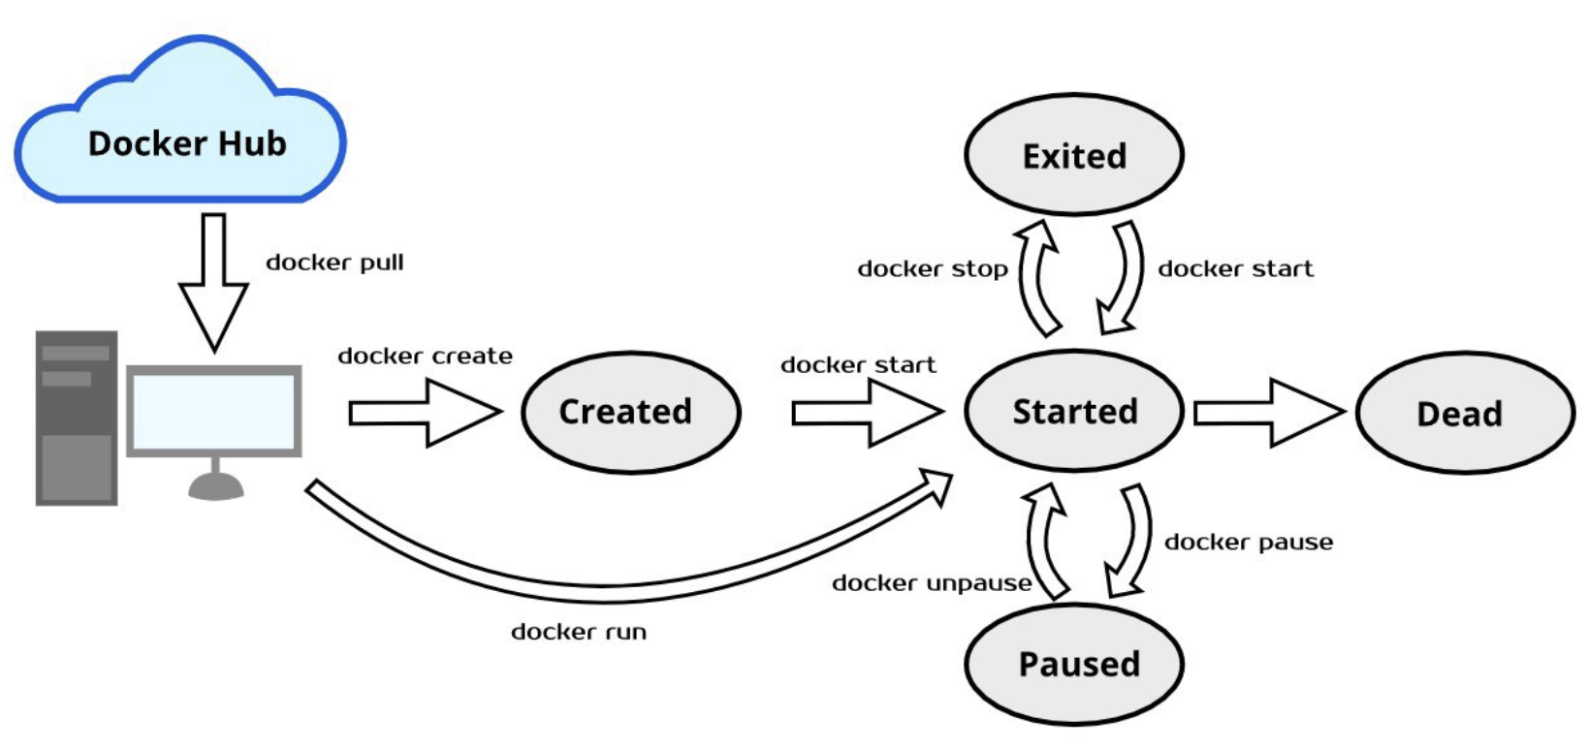
Picture credit: Get Started with Docker Lifecycle

- docker start starts a container so it is running.
- docker stop stops a running container.
- docker restart stops and starts a container.
- docker pause pauses a running container, "freezing" it in place.
- docker unpause will unpause a running container.
- docker wait blocks until running container stops.
- docker kill sends a SIGKILL to a running container.
- docker attach will connect to a running container.
Or we can use the following to get tty:
$ docker exec -i -t my-nginx-1 /bin/bash

Note that we used exec to run a command in a "running" container!

Image create/remove
- docker images : shows all images.
- docker import : creates an image from a tarball.
- docker build : creates image from Dockerfile.
- docker commit : creates image from a container, by default, the container being committed and its processes will be paused while the image is committed. This reduces the likelihood of encountering data corruption during the process of creating the commit. As an example, let's install nginx to the ubuntu container:
$ docker run -it ubuntu /bin/bash
root@bf5d24821dfa:/# apt-get update
root@bf5d24821dfa:/# apt-get install nginx

While the container is running, on another terminal, we can commit the change to another image:
$ docker ps
CONTAINER ID IMAGE COMMAND
bf5d24821dfa ubuntu "/bin/bash"

$ docker commit bf5d24821dfa ubuntu-nginx

$ docker images
REPOSITORY TAG IMAGE ID
ubuntu-nginx latest 91cc8b745f5e

$ docker run -it ubuntu-nginx
root@9644a814e95a:/#

$ docker ps
CONTAINER ID IMAGE COMMAND
9644a814e95a ubuntu-nginx "/bin/bash"
bf5d24821dfa ubuntu "/bin/bash"

Note the the new container dit not start "nginx" server. So, we can commit a container with new CMD and EXPOSE instructions:
root@9644a814e95a:/# exit

$ docker commit -m 'added nginx start' --change='CMD ["nginx", "-g daemon off;"]' -c "EXPOSE 80" 9644a814e95a ubuntu-nginx:version2

  - -m 'added nginx start' creates a comment for this commit.
  - --change='CMD ... is changing the CMD command, which is what the image will run when it is first started up. In this example, we are telling the image to run nginx in the foreground. Most base os images have CMD set to bash so we can interact with the os when attaching.
  - We used "EXPOSE" to get the port exposed to the host.
  - "9644a814e95a" is the name of the container we want to commit from.
  - "ubuntu-nginx:version2" is our name for the new image. We appended version to the name of the container.

We can now view our new image with the following command:
$ docker images
REPOSITORY TAG IMAGE ID
ubuntu-nginx version2 61918a284221

Run the new image:
$ docker run -idt ubuntu-nginx:version2

$ ps aux | grep -v grep |grep nginx
root 12546 0.0 0.2 124972 9560 pts/25 Ss+ 10:21 0:00 nginx: master process nginx -g daemon off;
www-data 12565 0.0 0.0 125332 3040 pts/25 S+ 10:21 0:00 nginx: worker process
www-data 12566 0.0 0.0 125332 3040 pts/25 S+ 10:21 0:00 nginx: worker process

$ docker inspect --format '{{ .NetworkSettings.IPAddress }}' $(docker ps -q)
172.17.0.2

We can see the index page:
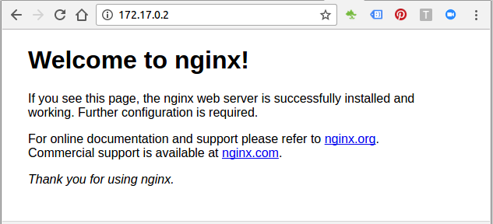
- docker rmi : removes (and un-tags) an image from the host node. If an image has multiple tags, using this command with the tag as a parameter only removes the tag. If the tag is the only one for the image, both the image and the tag are removed. This does not remove images from a registry. We cannot remove an image of a running container unless we use the -f option.
- docker load : loads an image from a tar archive as STDIN, including images and tags .
- docker save : saves an image to a tar archive stream to STDOUT with all parent layers, tags & versions.

Image info
- docker history shows history of image.
- docker tag tags an image to a name (local or registry).

Network create/remove/info/connection
- docker network create
- docker network rm
- docker network ls
- docker network inspect
- docker network connect
- docker network disconnect

Docker Repo
- docker login to login to a registry. (see docker push)
$ docker login --username=dockerbogo
Password:
Login Succeeded

- docker logout to logout from a registry.
$ docker logout
Removing login credentials for https://index.docker.io/v1/

- docker search searches registry for image.
$ docker search mysql
NAME DESCRIPTION STARS OFFICIAL AUTOMATED
mysql MySQL is a widely used, open-source relati... 2797 [OK]
mysql/mysql-server Optimized MySQL Server Docker images. Crea... 182 [OK]
...

- docker pull pulls an image from registry to local machine.
$ docker pull ubuntu
latest: Pulling from ubuntu
20ee58809289: Pull complete
f905badeb558: Pull complete
119df6bf2a3a: Pull complete
94d6eea646bc: Pull complete
bb4eabee84bf: Pull complete
Digest: sha256:85af8b61adffea165e84e47e0034923ec237754a208501fce5dbeecbb197062c
Status: Downloaded newer image for ubuntu:latest
Docker images can consist of multiple layers. In the example above, the image consists of five layers.

- docker push pushes an image to the registry from local machine. First, we'll install nginx on top of ubuntu, and then commit it. After login to DockerHub, we'll tag the image and push it:
$ docker run -it ubuntu:latest /bin/bash

root@846346c3482f:/# apt-get update
root@846346c3482f:/# apt-get install nginx

$ docker commit 846346c3482f ubuntu-with-nginx

$ docker images
REPOSITORY TAG IMAGE ID CREATED SIZE
ubuntu-with-nginx latest de412f7faba5 16 minutes ago 212 MB

$ docker login --username=dockerbogo
Password:
Login Succeeded

$ docker tag de412f7faba5 dockerbogo/ubuntu-with-nginx:myfirstpush

$ docker push dockerbogo/ubuntu-with-nginx:myfirstpush
The push refers to a repository [docker.io/dockerbogo/ubuntu-with-nginx]
44f391d61c42: Pushed
73e5d2de6e3e: Mounted from library/ubuntu
08f405d988e4: Mounted from library/ubuntu
511ddc11cf68: Mounted from library/ubuntu
a1a54d352248: Mounted from library/ubuntu
9d3227c1793b: Mounted from library/ubuntu
myfirstpush: digest: sha256:a24d914b8e3a013987314054b2c2409e99c00384342b25ee7dba4c51cb1ea49a size: 1569

We can check if the push was successful:
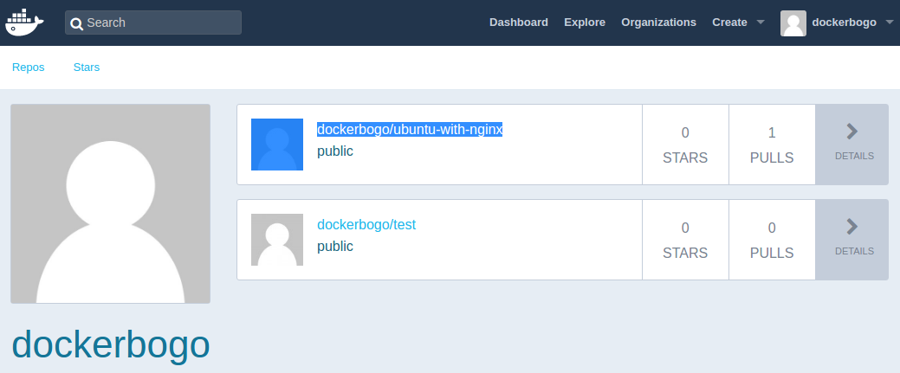

Where is /var/lib/docker on Mac/OS X?
Stackoverflow
On Max, the containers are stored within the VM located at:
$ ls -la ~/Library/Containers/com.docker.docker/Data/vms/0
total 16215008
drwxr-xr-x@ 17 kihyuckhong staff 544 Dec 16 10:42 .
drwxr-xr-x 3 kihyuckhong staff 96 Jul 31 15:03 ..
srwxr-xr-x 1 kihyuckhong staff 0 Dec 16 10:41 00000002.000005f4
srwxr-xr-x 1 kihyuckhong staff 0 Dec 16 10:41 00000002.00001001
srwxr-xr-x 1 kihyuckhong staff 0 Dec 16 10:41 00000002.00001003
srwxr-xr-x 1 kihyuckhong staff 0 Dec 16 10:41 00000003.000005f5
srwxr-xr-x 1 kihyuckhong staff 0 Dec 16 10:41 00000003.00000948
-rw-r--r-- 1 kihyuckhong staff 8331264000 Dec 20 16:46 Docker.qcow2
-rw-r--r-- 1 kihyuckhong staff 90112 Dec 16 10:41 config.iso
srwxr-xr-x 1 kihyuckhong staff 0 Dec 16 10:41 connect
drwxr-xr-x 2 kihyuckhong staff 64 Aug 5 20:31 data
lrwxr-xr-x 1 kihyuckhong staff 17 Dec 16 10:41 guest.000005f5 -> 00000003.000005f5
lrwxr-xr-x 1 kihyuckhong staff 17 Dec 16 10:41 guest.00000948 -> 00000003.00000948
-rw-r--r-- 1 kihyuckhong staff 2764 Dec 16 10:41 hyperkit.json
-rw-r--r-- 1 kihyuckhong staff 3 Dec 16 10:41 hyperkit.pid
drwxr-xr-x 2 kihyuckhong staff 64 Jul 31 15:03 log
lrwxr-xr-x 1 kihyuckhong staff 12 Dec 16 10:41 tty -> /dev/ttys004

$ screen ~/Library/Containers/com.docker.docker/Data/vms/0/tty

The command will show a blank window, just hit "Enter", then we get:
docker-desktop:~#

docker-desktop:~# cd /var/lib/docker

docker-desktop:/var/lib/docker# ls -la
total 124
drwx--x--x 15 root root 4096 Dec 16 18:42 .
drwxr-xr-x 10 root root 4096 Jul 31 22:03 ..
drwx------ 2 root root 4096 Jul 31 22:03 builder
drwx--x--x 4 root root 4096 Jul 31 22:03 buildkit
drwx------ 3 root root 4096 Jul 31 22:03 containerd
drwx------ 10 root root 4096 Dec 20 20:34 containers
drwx------ 3 root root 4096 Jul 31 22:03 image
drwxr-x--- 3 root root 4096 Jul 31 22:03 network
drwx------ 80 root root 49152 Dec 20 20:34 overlay2
drwx------ 4 root root 4096 Jul 31 22:03 plugins
drwx------ 2 root root 4096 Dec 16 18:42 runtimes
drwx------ 2 root root 4096 Jul 31 22:03 swarm
drwx------ 2 root root 4096 Dec 16 18:42 tmp
drwx------ 2 root root 4096 Jul 31 22:03 trust
drwx------ 14 root root 20480 Dec 15 18:43 volumes

Additional steps with a screen command:
# disconnect that session but leave it open in background
Ctrl-a d

# list that session that's still running in background
$ screen -ls
There is a screen on:
18887.ttys005.Kihyucks-MacBook-Air (Detached)
1 Socket in /var/folders/3s/42rgkz495lj4ydjgnqhxn_400000gn/T/.screen.

# reconnect to that session (don't open a new one, that won't work and 2nd tty will give you garbled screen)
$ screen -r 18887.ttys005.Kihyucks-MacBook-Air
[screen is terminating]

# kill this session (window) and exit
Ctrl-a k

Refs
https://docs.docker.com/engine/reference/commandline/docker/
https://www.bogotobogo.com/DevOps/Docker/Docker-Cheat-Sheet.php

Getting started with swarm mode
Estimated reading time: 3 minutes
This tutorial introduces you to the features of Docker Engine Swarm mode. You may want to familiarize yourself with the key concepts before you begin.
The tutorial guides you through the following activities:
- initializing a cluster of Docker Engines in swarm mode
- adding nodes to the swarm
- deploying application services to the swarm
- managing the swarm once you have everything running
This tutorial uses Docker Engine CLI commands entered on the command line of a terminal window.
If you are brand new to Docker, see About Docker Engine.

Set up
To run this tutorial, you need the following:
- three Linux hosts which can communicate over a network, with Docker installed
- the IP address of the manager machine
- open ports between the hosts

Three networked host machines
This tutorial requires three Linux hosts which have Docker installed and can communicate over a network. These can be physical machines, virtual machines, Amazon EC2 instances, or hosted in some other way. Check out Getting started - Swarms for one possible set-up for the hosts.
One of these machines is a manager (called manager1) and two of them are workers (worker1 and worker2).
Note: You can follow many of the tutorial steps to test single-node swarm as well, in which case you need only one host. Multi-node commands do not work, but you can initialize a swarm, create services, and scale them.

Install Docker Engine on Linux machines
If you are using Linux based physical computers or cloud-provided computers as hosts, simply follow the Linux install instructions for your platform. Spin up the three machines, and you are ready. You can test both single-node and multi-node swarm scenarios on Linux machines.

Use Docker Desktop for Mac or Docker Desktop for Windows
Alternatively, install the latest Docker Desktop for Mac or Docker Desktop for Windows application on one computer. You can test both single-node and multi-node swarm from this computer.
- You can use Docker Desktop for Mac or Windows to test single-node features of swarm mode, including initializing a swarm with a single node, creating services, and scaling services.
- Currently, you cannot use Docker Desktop for Mac or Docker Desktop for Windows alone to test a multi-node swarm, but many examples are applicable to a single-node Swarm setup.

The IP address of the manager machine
The IP address must be assigned to a network interface available to the host operating system. All nodes in the swarm need to connect to the manager at the IP address.
Because other nodes contact the manager node on its IP address, you should use a fixed IP address.
You can run ifconfig on Linux or macOS to see a list of the available network interfaces.
The tutorial uses manager1 : 192.168.99.100.

Open protocols and ports between the hosts
The following ports must be available. On some systems, these ports are open by default.
- TCP port 2377 for cluster management communications
- TCP and UDP port 7946 for communication among nodes
- UDP port 4789 for overlay network traffic
If you plan on creating an overlay network with encryption (--opt encrypted), you also need to ensure ip protocol 50 (ESP) traffic is allowed.

What’s next?
After you have set up your environment, you are ready to create a swarm.

Create a swarm
Estimated reading time: 2 minutes
After you complete the tutorial setup steps, you’re ready to create a swarm. Make sure the Docker Engine daemon is started on the host machines.
- Open a terminal and ssh into the machine where you want to run your manager node. This tutorial uses a machine named manager1. If you use Docker Machine, you can connect to it via SSH using the following command:
- docker-machine ssh manager1
- Run the following command to create a new swarm:
docker swarm init --advertise-addr <MANAGER-IP>
Note: If you are using Docker Desktop for Mac or Docker Desktop for Windows to test single-node swarm, simply run docker swarm init with no arguments. There is no need to specify --advertise-addr in this case. To learn more, see the topic on how to Use Docker Desktop for Mac or Docker Desktop for Windows with Swarm.
In the tutorial, the following command creates a swarm on the manager1 machine:
docker swarm init --advertise-addr 192.168.99.100
- The --advertise-addr flag configures the manager node to publish its address as 192.168.99.100. The other nodes in the swarm must be able to access the manager at the IP address.
The output includes the commands to join new nodes to the swarm. Nodes will join as managers or workers depending on the value for the --token flag.
- Run docker info to view the current state of the swarm:
docker info
Run the docker node ls command to view information about nodes:
docker node ls
- The * next to the node ID indicates that you’re currently connected on this node.
Docker Engine swarm mode automatically names the node for the machine host name. The tutorial covers other columns in later steps.

What’s next?
In the next section of the tutorial, we add two more nodes to the cluster.

Add nodes to the swarm
Estimated reading time: 2 minutes
Once you’ve created a swarm with a manager node, you’re ready to add worker nodes.
- Open a terminal and ssh into the machine where you want to run a worker node. This tutorial uses the name worker1.
- Run the command produced by the docker swarm init output from the Create a swarm tutorial step to create a worker node joined to the existing swarm:
docker swarm join \
--token SWMTKN-1-49nj1cmql0jkz5s954yi3oex3nedyz0fb0xx14ie39trti4wxv-8vxv8rssmk743ojnwacrr2e7c \
192.168.99.100:2377
If you don’t have the command available, you can run the following command on a manager node to retrieve the join command for a worker:
docker swarm join-token worker
- Open a terminal and ssh into the machine where you want to run a second worker node. This tutorial uses the name worker2.
- Run the command produced by the docker swarm init output from the Create a swarm tutorial step to create a second worker node joined to the existing swarm:
docker swarm join \
--token SWMTKN-1-49nj1cmql0jkz5s954yi3oex3nedyz0fb0xx14ie39trti4wxv-8vxv8rssmk743ojnwacrr2e7c \
192.168.99.100:2377
Open a terminal and ssh into the machine where the manager node runs and run the docker node ls command to see the worker nodes:
docker node ls
- The MANAGER column identifies the manager nodes in the swarm. The empty status in this column for worker1 and worker2 identifies them as worker nodes.
Swarm management commands like docker node ls only work on manager nodes.

What’s next?
Now your swarm consists of a manager and two worker nodes. In the next step of the tutorial, you deploy a service to the swarm.

Deploy a service to the swarm
After you create a swarm, you can deploy a service to the swarm. For this tutorial, you also added worker nodes, but that is not a requirement to deploy a service.
- Open a terminal and ssh into the machine where you run your manager node. For example, the tutorial uses a machine named manager1.
- Run the following command:
docker service create --replicas 1 --name helloworld alpine ping docker.com
- The docker service create command creates the service.
- The --name flag names the service helloworld.
- The --replicas flag specifies the desired state of 1 running instance.
- The arguments alpine ping docker.com define the service as an Alpine Linux container that executes the command ping docker.com.
- Run docker service ls to see the list of running services:
docker service ls

What’s next?
Now you’ve deployed a service to the swarm, you’re ready to inspect the service.

Inspect a service on the swarm
Estimated reading time: 2 minutes
When you have deployed a service to your swarm, you can use the Docker CLI to see details about the service running in the swarm.
- If you haven’t already, open a terminal and ssh into the machine where you run your manager node. For example, the tutorial uses a machine named manager1.
- Run docker service inspect --pretty <SERVICE-ID> to display the details about a service in an easily readable format.
To see the details on the helloworld service:
docker service inspect --pretty helloworld
Tip: To return the service details in json format, run the same command without the --pretty flag.
docker service inspect helloworld
Run docker service ps <SERVICE-ID> to see which nodes are running the service:
docker service ps helloworld
- In this case, the one instance of the helloworld service is running on the worker2 node. You may see the service running on your manager node. By default, manager nodes in a swarm can execute tasks just like worker nodes.
Swarm also shows you the DESIRED STATE and CURRENT STATE of the service task so you can see if tasks are running according to the service definition.
- Run docker ps on the node where the task is running to see details about the container for the task.
Tip: If helloworld is running on a node other than your manager node, you must ssh to that node.
docker ps

What’s next?
Next, you can change the scale for the service running in the swarm.

Scale the service in the swarm
Once you have deployed a service to a swarm, you are ready to use the Docker CLI to scale the number of containers in the service. Containers running in a service are called “tasks.”
- If you haven’t already, open a terminal and ssh into the machine where you run your manager node. For example, the tutorial uses a machine named manager1.
- Run the following command to change the desired state of the service running in the swarm:
docker service scale <SERVICE-ID>=<NUMBER-OF-TASKS>
For example:
docker service scale helloworld=5
Run docker service ps <SERVICE-ID> to see the updated task list:
docker service ps helloworld
- You can see that swarm has created 4 new tasks to scale to a total of 5 running instances of Alpine Linux. The tasks are distributed between the three nodes of the swarm. One is running on manager1.
- Run docker ps to see the containers running on the node where you’re connected. The following example shows the tasks running on manager1:
docker ps
- If you want to see the containers running on other nodes, ssh into those nodes and run the docker ps command.

What’s next?
At this point in the tutorial, you’re finished with the helloworld service. The next step shows how to delete the service.
https://docs.docker.com/engine/swarm/swarm-tutorial/scale-service/

